Chair Academy Participants
Fall 2017
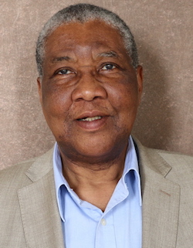
Chike Anyaegbunam is a Professor in the Integrated Strategic Communication program of the UK School of Journalism and Telecommunications. He teaches undergraduate and graduate courses including public relations and participatory communication. He also specializes in designing participatory communication strategies and media for rural community outreach projects related to civic engagement, agricultural safety and health, and economic well-being.
Chike earned his Ph.D. in Journalism and Mass Communication from the University of Iowa, 1994 and has served as a rural communication adviser for a variety of national and international development projects funded by the Pfizer and Robert Wood Johnson Foundations, the National Cancer Institute (NCI) through the Appalachian Cancer Network, the World Bank, the United Nations, and the United States Agency for International Development (USAID). He is currently the director of a national social marketing program to promote tractor safety funded by NIOSH/CDC through the UK Southeast Center for Agricultural Health and Injury Prevention.
He was the 1992-93 editor of the Journal of Communication Inquiry and is the lead author of a book on participatory rural communication research. He has also co-authored articles published in several academic journals and book chapters on participatory rural communication research. His research and community development efforts have garnered awards and fellowships from the UK College of Communications and Information Studies, UK Office of the VP for Research, Association for Education in Journalism and Mass Communication (AEJMC) and Broadcast Education Association (BEA).
Email: canya2@uky.edu
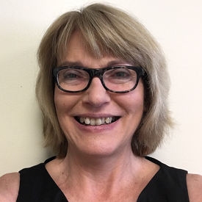
Terry Bunn PhD Dr. Terry Bunn is an Associate Professor in the Department of Preventive Medicine and Environmental Health and the Director of the Kentucky Injury Prevention and Research Center (KIPRC). She is the Principal Investigator for the Kentucky Occupational Safety and Health Surveillance, Fatality Assessment and Control Evaluation, Core Violence and Injury Prevention, and State Injury Prevention programs. Terry is currently working in the areas of injury and illness surveillance and prevention, including the prevention of motor vehicle injuries, and drug poisonings in both the general and working populations.

Research Interests
Terry Bunn is specifically interested in risk factors contributing to occupationally-related motor vehicle crash, road and highway construction, machinery and youth fatalities occurring in the state of Kentucky with an emphasis on development of strategies for prevention.
Email Address: tlbunn2@email.uky.edu

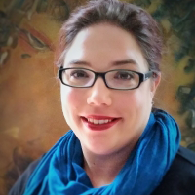

Heather Bush PhD Dr. Bush is an Associate Professor in the Department of Biostatistics. Prior to her appointment, she worked as a senior statistician for a clinical research organization specializing in Phase IV clinical trials and health registries, where she became interested in methodological issues associated with investigating health outcomes in large, complex databases. Her research interests include clinical trials and outcomes research, especially in the areas of Women's Health and Sports Related Injuries. Dr. Bush also serves as the co-director for both Biostatistics, Epidemiology, and Research Design key function of the Center for Clinical and Translational Science and the Applied Statistics Lab.

Email: Heather.Bush@uky.edu

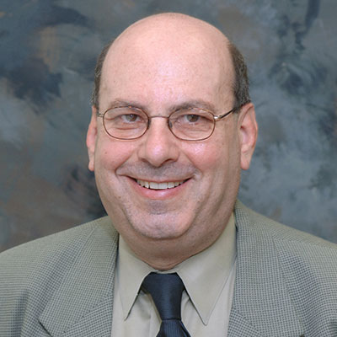
Ralph Crystal, Ph.D., CRC Dr. Crystal is the Rehabilitation Counseling Program Coordinator and the Director of Graduate Studies for the Department of Early Childhood, Special Education, and Rehabilitation Counseling. He received his bachelor’s degree in psychology from Pace University (1970), master’s degree in rehabilitation counseling from New York University (1972), and doctoral degree in rehabilitation psychology from the University of Wisconsin-Madison (1977).
After completing his master’s degree he worked at a facility serving persons with physical, mental, and learning disabilities with regarding to vocational assessment, vocational counseling, job training, and job placement. After completing his doctoral degree he was employed at the University of Michigan where he served as research director of a rehabilitation research institute with a focus on the evaluation of public rehabilitation programs. He was also on the faculty of the rehabilitation counseling program.
In 1981, Dr. Crystal was appointed as coordinator of the rehabilitation counseling program at the University of Kentucky. In 1995, Dr. Crystal was instrumental in establishing a distance education program in partnership with the two state rehabilitation agencies in the Commonwealth of Kentucky. This program has evolved into a nationally recognized web based master’s degree program.
Dr. Crystal oversaw the reaccreditation of the Rehabilitation Counseling program in 2013. He is currently leading the faculty initiative to obtain accreditation for the program as a duly accredited Clinical Mental Health Rehabilitation Counseling and Clinical Rehabilitation Counseling program.
Dr. Crystal has published in the area of rehabilitation program evaluation, consumer satisfaction, healthcare and disability, and forensic rehabilitation. Dr. Crystal is a Commissioner with the Council on Rehabilitation Education and reviews Rehabilitation Counseling programs for accreditation. Dr. Crystal also maintains a private rehabilitation practice.

Email: ralph.crystal@uky.edu

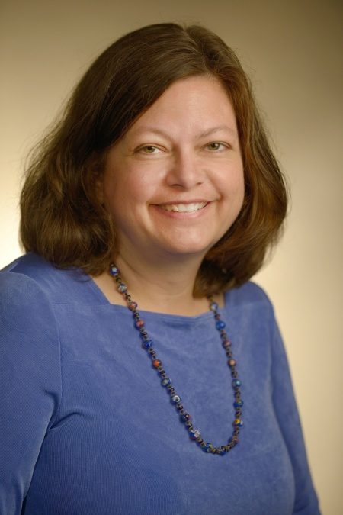

Rebecca Dutch Professor, Molecular & Cellular Biochemistry.
The central focus of our research is the synthesis, folding, processing and function of viral glycoproteins. Previous studies of the synthesis and processing of viral glycoproteins in the secretory pathway have led to fundamental discoveries of basic cellular processes, and our research on the folding and processing of paramyxovirus glycoproteins provides insight into both cellular functions and important viral proteins. Our studies on viral proteins aim to elucidate mechanisms of promotion of membrane fusion, and to provide new targets for antiviral treatments.
Many major human pathogenic viruses (including HIV, herpes simplex virus, measles virus and Ebola virus) are packaged in a membrane. In order for these viruses to infect cells, specific viral proteins promote fusion of the viral membrane with the membrane of the host cell. Understanding this process of protein-mediated membrane fusion is the major focus of our work. We study fusion proteins from several different paramyxoviruses. First, we are examining the fusion protein from the Hendra and Nipah viruses, newly emerged diseases in the paramyxovirus family that are highly pathogenic in multiple species including humans, and which are classified as Biosafety Level 4 pathogens. Our laboratory has identified cathepsin L, a cellular endosomal/lysosomal protease, as critical protein for activation of the Hendra and Nipah fusion proteins, and thus a potential drug target. We are also studying the F protein from the paramxyovirus SV5, for which multiple mutants have been made and for which several atomic structures are now known. Finally, we have initiated study of the glycoproteins from human metapneumovirus, a recently identified virus that is a causative agent of severe respiratory disease in infants and young children. Our long-term goal is to understand the specific molecular events in these important membrane fusion processes.

Email: rdutc2@uky.edu

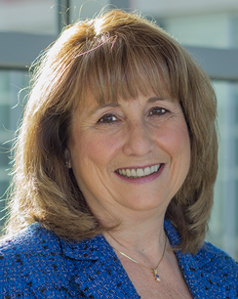

Jan Odom-Forren PhD, RN, CPAN, FAAN

Jan Odom Forren received her BSN from Mississippi College and MSN from the University of Southern Mississippi. She received a PhD in nursing from the University of Kentucky, focusing on post discharge nausea and vomiting in ambulatory surgical patients. Dr.Forren began teaching at UK as an adjunct in 2008 and then became an assistant professor in 2010. Before coming to UK, she was a staff nurse in PACU; clinical nurse specialist, perioperative services; nurse manager, PACU; and Director, Surgical Services. She is an international lecturer on perianesthesia and sedation issues and has published extensively in journals and books. Her research area of interest is management of postoperative symptoms, and her research for her dissertation focused on post discharge nausea and vomiting. Dr. Forren is past president of the American Society of PeriAnesthesia Nurses and has served that organization in many capacities. She most recently has been a member of strategic work teams who developed ASPAN sponsored evidence-based guidelines on the management of PONV/PDNV and perioperative normothermia. She is a Fellow in the American Academy of Nursing and is currently a co-editor of the Journal of PeriAnesthesia Nursing. She is author/editor of 2 books: Practical Guide to Moderate Sedation/Analgesia, edition two; and Drain's The PACU: A Critical Care Approach, edition 6. Recently, Dr. Forren received funding to study Postoperative Symptom Management in Orthopaedic and Laparoscopic Cholecystectomy Ambulatory Surgery patients
Email: Jan.Forren@uky.edu

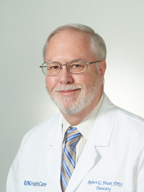

Robert Q. Frazer, DDS
Chief, Division of Prosthodontics
Interim Chair, Department of Oral Health Practice. I received my dental degree from the University of Colorado, School of Dentistry, Denver. My clinical interests include prosthodontics.
Email: rfrazer@uky.edu

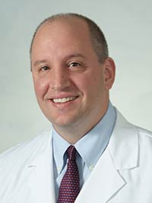
Peter Giannone, MD I received my medical degree from SUNY Health Science Center at Syracuse, College of Medicine, Syracuse, N.Y. I completed a fellowship in neonatology at Brown University, Women and Infant's Hospital of Rhode Island, Providence. I am board certified by the American Board of Pediatrics in General Pediatrics and Neonatal-Perinatal Medicine.
I came to UK HealthCare from Ohio State University where I served as Medical Director of the NICU. I have been continually externally funded for the last ten years to support my research interests which are comprised of necrotizing enterocolitis and brain injury in preterm infants.
My clinical interests include care of the extremely preterm infant and newborn resuscitation. I currently serve as Chief of the Division of Neonatology and Vice Chair of Pediatric Research at Kentucky Children’s Hospital.
Email: peter.giannone@uky.edu

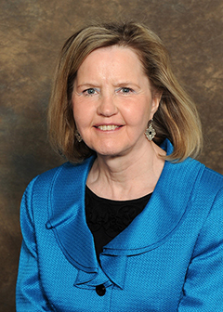

Debra Hampton PhD, MSN, RN, FACHE, NEA-BC

Debra Hampton received her MSN and PhD in nursing degrees from the University of Cincinnati College of Nursing. Dr. Hampton is an experienced nursing leader, having served as a first line manager, middle manager, chief nursing officer, and as a senior executive (System Site CEO). As a seasoned educator, she has developed and taught various courses as a part-time instructor since 1996 for the College’s undergraduate, master’s and DNP programs. Dr. Hampton currently teaches full time in the DNP Program, including courses in technology/informatics, finance, leadership and others, and she coordinates the Executive Nursing Leadership Population & Organizational Systems DNP Track as well as the MSN-DNP Clinical and Executive Nursing Leadership Tracks. Dr. Hampton has also worked as a full-time assistant professor in the online graduate program at Loyola University New Orleans and part time as an adjunct assistant professor in the online RN-to-BSN Program at Our Lady of the Lake College in Baton Rouge, Louisiana.

Email: debra.hampton@uky.edu

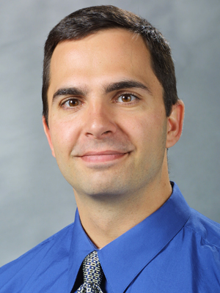

Don Helme PhD
Education
BA, 1993, Michigan State University; MA, 1996, Eastern Michigan University; PhD, 2000, University of Kentucky
Specialties
health campaigns, persuasive messages, adolescent substance abuse, anti-tobacco coalitions, physician-patient communication
Awards
College of Communication and Information Faculty Community Service Award 2017; Top Paper, Health Communication Division, International Communication Association 2010

Email: Don.Helme@uky.edu

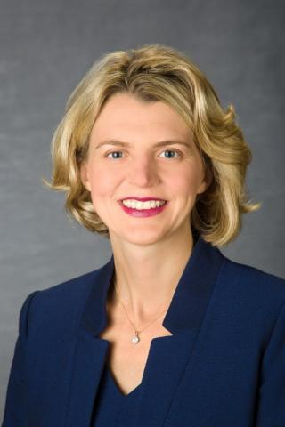

Jennifer Hunter PhD

Jennifer Hunter serves the University of Kentucky College of Agriculture, Food and Environment and the School of Human and Environmental Sciences as an Associate Professor in Family Sciences, State Extension Specialist for Family Financial Management, and Director of the Managing in Tough Times Initiative.

Jennifer has been at the University of Kentucky since 2001. She has her BS, MS, and PhD from the University of Kentucky. Jennifer’s background includes a large cross-section of Extension experience, ranging from county agent to state specialist. She has held primary appointments in the three principal Extension-programming areas, 4-H Youth Development, Family and Consumer Sciences, and Agriculture and Natural Resources.

She has over 150 print and electronic publications and has conducted over 800 Extension educational programs. She teaches a course in family resource management and is active in student advising.

Jennifer's professional and research interest primarily focus on household financial management and student financial wellness.

Email: jhunter@uky.edu

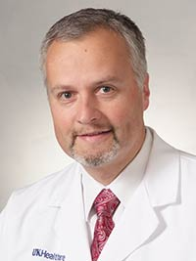

Stefan G. Kiessling, MD Chief, Division of Pediatric Nephrology

I received my medical degree from the Friedrich-Alexander University, Erlangen Germany. I completed a residency in pediatrics at Kentucky Children’s Hospital. Thereafter, I completed a fellowship in pediatric nephrology at The Children's Hospital in Boston.

I am board certified by the American Board of Pediatrics in General Pediatrics as well as Pediatric Nephrology.

Clinical interests
- Chronic Renal Insufficiency
- Hypertension Management
- Pediatric Kidney Transplantation
- Pediatric Nephrology

Email: skies2@email.uky.edu

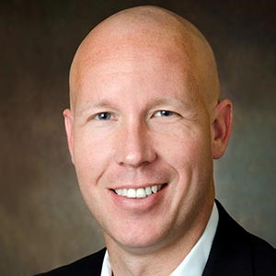

Craig Martin, PharmD

Dr. Martin serves in a joint role as Director of Professional Practice Development for both UK College of Pharmacy and UK HealthCare Pharmacy Services. In this role he develops and oversees clinical practice sites for College of Pharmacy faculty, serves as administrative director for UK Pharmacy Residencies, and leads professional development initiatives for UK HealthCare pharmacy staff. As a Board Certified Pharmacotherapy Specialist with Added Qualifications in Infectious Diseases, Dr. Martin remains active in the clinical arena by working with UK HealthCare’s Infectious Diseases Division and Infection Prevention and Control staff. Since 2002, he has helped lead the nationally-recognized UK HealthCare Antimicrobial Stewardship Program. Dr. Martin is a recipient of American Society of Health-System Pharmacists’ “Best Practice Award” for 2004 as well as the Society of Infectious Diseases Pharmacists’ “Outstanding Clinical Practice in Infectious Diseases Pharmacotherapy” award for 2005 and the Kentucky Society of Health Systems Pharmacists’ “Pharmacist of the Year” award for 2010. A native Kentuckian, Dr. Craig Martin received his Doctor of Pharmacy degree from the University of Kentucky College of Pharmacy in 1999 and completed an Infectious Diseases Specialty Residency at UK in 2002.

Email: craig.martin@uky.edu

Carl Mattacola, PhD, ATC, FNATA
Dr. Mattacola is a Professor and the Associate Dean of Academic and Faculty Affairs at the University of Kentucky. He received his bachelor's degree in physical education/athletic training from Canisius College in Buffalo, New York. He completed his doctor of philosophy degree in sports medicine and received his masters of education degree, both at the University of Virginia. Dr. Mattacola has held various positions as an athletic trainer and as a professor, including Temple University in Pennsylvania, Hampden-Sydney College, and Woodberry Forest School in Virginia.
His research has focused on postural and functional considerations in the treatment and rehabilitation of lower extremity injury and the study of cognitive, functional, and safety interventions for jockeys. He will continue to explore factors that relate to athletic injuries and rehabilitation, focusing primarily on issues related to the lower extremity.
Scholarly Interest
Neuromuscular Control/Movement Science — Examines the neuromuscular control of the lower extremity as it relates to balance and postural sway
Examination of the effects of rehabilitation interventions (e.g. exercise and orthotics) on balance and postural sway
Email: carlmat@uky.edu

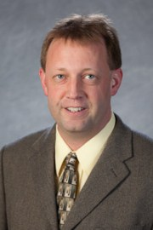

Michael Montross, Ph.D., P.E.
My research can be divided into two main areas:
1. Drying, storage, and granular mechanics of grains and oilseeds, and
2. Biomass collection, characterization, and processing.
Two specific new areas of research are to create controlled environment experiments designed to simulate environmental conditions for different regions of the U.S. to be performed for switchgrass and forage sorghum and to obtain new field and laboratory data to refine and calibrate a science-based model for determining the packing of grains within upright storage structures.
Keywords: Grain Drying, Grain Storage, Biomass Harvest, Biomass Storage, Harvest Logistics
Email: michael.montross@uky.edu

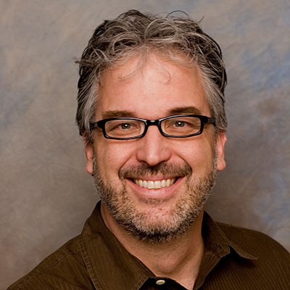

John Nash, Ph.D.
John B. Nash is an associate professor in the Department of Educational Leadership Studies. He teaches a range of courses on school technology leadership, design thinking and research methods. His current research agenda investigates how technology, innovation and policy interact and influence schools and educators in different contexts. John is also a director of the UCEA Center for Advanced Study of Leadership for Technology in Education (CASTLE) and the Laboratory on Design Thinking in Education (dLab).
John is the former Associate Director for Evaluation at the Stanford Center for Innovations in Learning (SCIL), where he conducted applied research on improving program evaluation in grant-funded initiatives, and the former Associate Director of Assessment and Research at the Stanford Learning Laboratory, where he examined the effects of innovative technologies on learning. He was also a grantmaker for the Wallenberg Global Learning Network, an arm of the Knut and Alice Wallenberg Foundation of Stockholm, Sweden, focused on enhancing learning outcomes through educational technology in the U.S., Sweden and Germany.
Email: john.nash@uky.edu

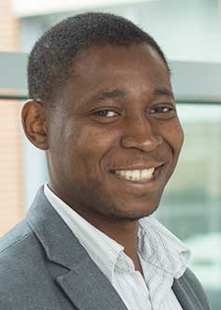

Chizimuzo Okoli PhD, MPH, MSN, RN

Chizimuzo (Zim) Okoli received his undergraduate degrees in nursing and philosophy from the University of Kentucky. He subsequently earned a Master of Science in Public Health, Master of Science in Nursing, and in 2005, his Doctor of Philosophy in Nursing, all from UK. In 2008 he completed a Canadian Institute of Health Research (CIHR) postdoctoral traineeship in tobacco research at the University of British Columbia. In 2010 he further completed a CIHR postdoctoral fellowship in gender, mental health and addictions through the University of British Columbia. Dr. Okoli is an assistant professor in the UK College of Nursing and he directs the Tobacco Treatment and Prevention Division of the Tobacco Policy Research Program. He has been involved in several studies addressing secondhand tobacco smoke (SHS) exposure policy in indoor and outdoor public spaces as well as using biomarkers of tobacco exposure. More recently, he has conducted several studies evaluating tobacco dependence treatment among marginalized populations, often individuals with substance use disorders and/or psychiatric disorders. His particular interests include examining how sex and gender affect tobacco dependence treatment outcomes. Dr. Okoli received a young investigators award to present at the Eighth Asian Pacific Association for the Control of Tobacco Triennial Conference in Taipie, Taiwan in 2007. He is co-principal investigator on a CIHR Operating Grant to examine the health and health equity effects of an outdoor smoke-free policy in parks and beaches.

Email: ctokol1@uky.edu

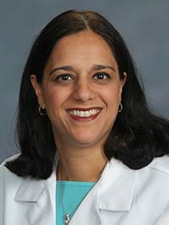

Sara S. Salles, DO
My name is Sara S. Salles; I received my doctor of osteopathic degree from Kansas City University of Medicine and Biosciences, College of Osteopathic Medicine, Kansas City, Mo. I am board certified by the American Board of Physical Medicine and Rehabilitation.
My research interests include Spinal Cord Injury and Spasticity and Movement Disorders. I have reviewed manuscripts for several notable journals including the Physical Medicine & Rehabilitation Journal and the Knowledge Now, Physical Medicine & Rehabilitation of the American Association of Physical Medicine & Rehabilitation and the Journal of Spinal Cord Medicine.
I am a diplomate of the American Academy of Physical Medicine and Rehabilitation and a member of the American Spinal Cord Injury Professionals, American Medical Association, American Osteopathic Association, American Paraplegia Society, Kentucky Osteopathic Association and the Association of Osteopathic Directors of Medical Education. I have published over 30 journal entries.
Email: sara.salles@uky.edu

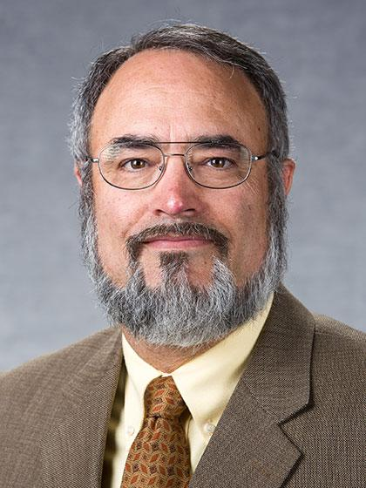

Jeffrey W. Stringer, Ph.D.

Education
Ph.D. Plant Physiology/Biochemistry/Molecular Biology Program 1993, University of Kentucky
M.S. Forestry 1981, University of Kentucky
B.S. Forestry 1979, University of Kentucky

Extension Responsibilities
Hardwood Silviculture.
Dr. Stringer specializes in hardwood silviculture, forest operations, and best management practices. His work includes research in his areas of specialization and the development of continuing education programs for forest owners, forestry and natural resource professionals. He is currently director of the Kentucky Master Logger Program and editor of the Kentucky LogJam Newsletter. He is also the managing editor of the Kentucky Woodlands Magazine.
Email: stringer@uky.edu

Clayton Thyne, PhD
Welcome. I am an Associate Professor in the Political Science department at the University of Kentucky. I also serve as the Director of Graduate Studies and the Director of the Peace Studies program at UK . My research currently focuses on domestic conflict/instability, coups d'état, regime types and democratization, and international education policy. You can find a list of my published and working papers at the link on the right.
My most recent work has been focused on coups d'état, civil war onset, and civil war duration. My book, How International Relations Affect Civil Conflict: Cheap Signals, Costly Consequences, was published by Lexington Books in 2009. Other published work can be found in The Journal of Politics, The British Journal of Political Science, Social Science Quarterly, International Studies Quarterly, The Journal of Conflict Resolution, Comparative Political Studies, The Journal of Peace Research, Foreign Policy Analysis, and Conflict Management and Peace Science.
My teaching interests are diverse. At the graduate level, I have taught our introductory statistics course, our introductory IR seminar, and a seminar on Civil Conflict. At the undergraduate level, I have taught our introductory IR course, Contemporary Global Conflicts, Civil Conflict, and Introduction to Peace Studies.
Email: clayton.thyne@uky.edu

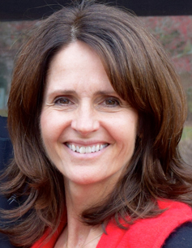

Lee Anne Walmsley PhD, MSN, RN

Lee Anne Walmsley received her BSN from the University of Kentucky in 1978. She earned her EdS, MSN, and PhD at the University of Kentucky in 2003, 2006 and 2015 respectively. She worked in a variety of medical surgical settings including a neonatal intensive care unit in Birmingham, England. This provided a wide variety of experience and after obtaining her MSN from UK in 2000, she began teaching as a clinical instructor and lecturer. She is currently the coordinator of the Second Degree Option in the undergraduate program and enjoys working with nontraditional students teaching fundamentals in the clinical setting. Dr. Walmsley is interested in adult learners and educational research. She is an associate of the Center for Interprofessional Health Education and serves as an Academic-Clinical Partner for Scholarship with UK HealthCare. She collaborates with colleagues at the College of Nursing who examine psychological well-being, anxiety and depression.

Email: lee.walmsley@uky.edu

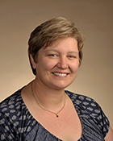

Donna M. Wilcock, Ph.D.
Position(s):
Associate Professor
Sweeney-Nelms Professor in Alzheimer's Disease Research

Affiliation(s):
Physiology
Sanders-Brown Center on Aging/Alzheimer’s Disease Research Center

Interests / Specialties:
Vascular cognitive impairment and dementia
Alzheimer's disease
Neuroinflammation

Email: donna.wilcock@uky.edu

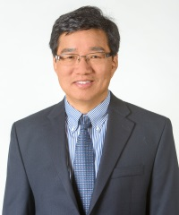

Guigen Zhang Joins F. Joseph Halcomb III, M.D. Department of Biomedical Engineering
Guigen Zhang, professor and associate chair of Department of Bioengineering at Clemson University, has joined the University of Kentucky College of Engineering as the inaugural F. Joseph Halcomb III, M.D. Chair in Biomedical Engineering, and the Department Chair of the F. Joseph Halcomb III, M.D. Department of Biomedical Engineering (BME). He began his duties August 1. The endowed chair is part of a $7 million commitment from alumnus Joe Halcomb and his wife, Joani, announced in April 2016.
Zhang is a fellow of the American Institute for Medical and Biological Engineering, and a national leader. He currently serves as the executive editor of Biomaterials Forum, and the president of the Institute of Biological Engineering. Zhang pursues research to advance biomedical engineering and innovation through utilization of integrated investigative approaches based on coupled experimentation and computation. He has published extensively in the areas of biomechanics, biomaterials and biosensors. Over the years, his research has been funded by diverse funding sources ranging from federal agencies such as National Institutes for Health and National Science Foundation, to private foundations like the Bill and Melinda Gates Foundation, to venture groups and major industry. Zhang holds numerous patents and has published three books, the latest of which is a textbook on “Introduction to Integrative Engineering” just published by the CRC Press.
Email: gz.tigerbio@gmail.com

