2019 Chairs’ Academy
Participants

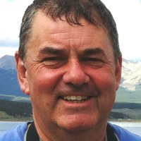
Jonathan Allison, Professor and Chair of the Department of English, has been a faculty member at UK since 1988. He was appointed Chair of English in Fall 2019. His research area is Modern British and Irish Literature, especially the writings of W.B. Yeats and the Revival, the Auden generation (including Louis MacNeice), and Irish writing since 1939. He teaches courses on twentieth-century writing, and the Survey of British Literature, 1750-2000. Dr. Allison has served as Interim Director of the University Press of Kentucky (2015-2016), former Chair of the Editorial Board of the University Press, and a member of the University of Kentucky Libraries National Advisory Board. He was general editor of the series Irish Literature, History and Culture. In 2017, he hosted the Southern regional meeting of the American Conference for Irish Studies at the University of Kentucky.

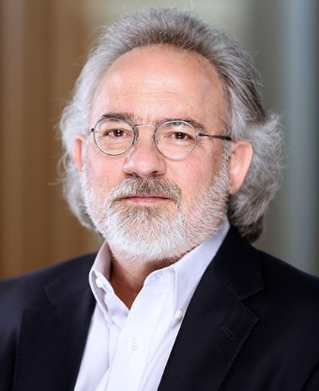
Stephen P. Borgatti is the Paul Chellgren Endowed Chair of Management of Strategy and Professor of Economics in the Management Department of the Gatton College of Business and Economics. He received his B.A. in Anthropology at Cornell and earned his Ph.D. in Mathematical Social Science at the University of California, Irvine. Dr. Borgatti moved to Kentucky in 2007 from Boston, where he was teaching at Boston College. His research is focused on social networks, particularly in the context of organizations.

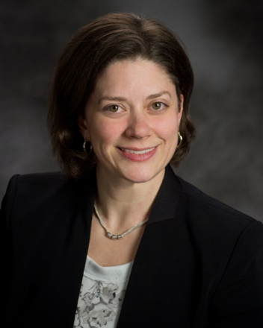
Jay-Marie Bravent (formerly Jaime Marie Burton) currently serves as Director of Research Services & Education at the Special Collections Research Center (SCRC), providing leadership for the staff of the Breckinridge Research Room, instruction programs, and print collections. Jay-Marie previously served as Education and Outreach Archivist at the SCRC, College Archivist and Assistant Professor at Berea College, and Assistant Special Collections Librarian at the Maryland Historical Society. Jay-Marie is a Certified Archivist and holds a Master of Arts in Historical Studies from the University of Maryland, Baltimore County with a concentration in Public History/Policy Administration, and has served on the board of the Kentucky Council on Archives since 2012.

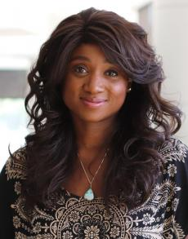
Camille Burnett, PhD, MPA, APHN-BC, RN, BScN, DSW is an Associate Professor in the College of Nursing at the University of Kentucky with an appointment as a Strategic Advisor for Community Engagement and Academic Partnerships with the Office of the Provost and a researcher at the Center for Health Equity Transformation and the Center for Clinical and Translational Science. Dr. Burnett received her PhD from the University of Western Ontario, her Masters at the University of Western Ontario, and her BScN from the University of Alberta.
She has extensive professional experience in public health including teaching, board appointments, management, research and consulting. Her portfolio centers on community engagement within a population and public health framework aimed at mitigating health disparities and inequity to improve health outcomes of the most vulnerable populations. Using a population and public health perspective, Dr. Burnett’s leadership and scholarship examines how structural influences shape policy, through intended and unintended consequences exposing hidden and often invisibly embedded bias, exclusion and marginalization.

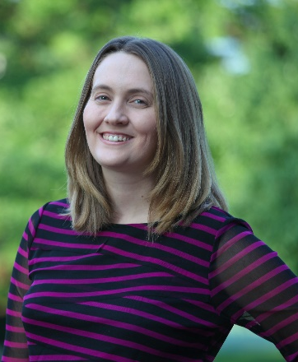
Jennifer Cramer is an associate professor and chair of the Department of Linguistics in the College of Arts & Sciences. She served as Director of Undergraduate Studies in the department prior to her appointment as chair. She is a former participant in both the Bluegrass Higher Education Consortium’s Academic Leadership Academy and UK’s Women Executive Leadership Development program. Her teaching and research are centered on the study of the interaction between language and society, and she focuses on the perception and production of linguistic variation at dialect and regional borders, with a specific interest in the dialects spoken in Kentucky.

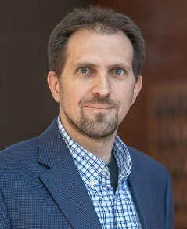
Dr. Thomas Dziubla, Ph.D. is Professor of Chemical Engineering and the Chair of the Department of Chemical and Materials Engineering at the University of Kentucky. He received his B.S. and Ph.D. in Chemical Engineering from Purdue University (1998) and Drexel University (2002), respectively. In 2002–2004, he was an NRSA postdoctoral fellow in the Institute for Environmental Medicine at the University of Pennsylvania School of Medicine, where he worked on the design of degradable polymeric nanocarriers for the delivery of antioxidants. His research group is interested in the design of new functional polymeric biomaterials which can actively control local cellular oxidative stress for improved biomaterial integration and disease treatment. In 2019, he was inducted into the American Institute for Medical and Biological Engineering College of Fellows. He holds 7 patents, has authored over 75 peer reviewed publications, has edited a book on Oxidative Stress and Biomaterials, and is an editor of the Journal of Biomedical Materials Research Part B. Along with Dr. Zach Hilt, he is the Co-founder of Bluegrass Advanced Materials, LLC, a company that is currently developing and commercializing technologies based upon research from their laboratories.

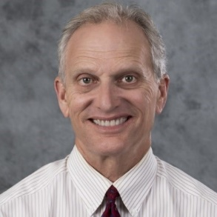
Robert “Tony” English, PT, PHD has been a faculty member in the Department of Physical Therapy at the University of Kentucky since 1992 and currently is an associate professor. He received a BS in Physical Therapy from the University of Texas Medical Branch in Galveston, Texas in 1978 and a MS in Education from the University of Kentucky in 1990. Tony completed his dissertation titled “Clinical functional testing in people 30-60 years old: Expected performance values and correlations to muscle fitness and activity level,” and received his PhD in Rehabilitation Sciences from the University of Kentucky in 2008.

Heather Erwin earned her Ph.D. in 2006 from the University of Illinois at Urbana-Champaign in Pedagogical Kinesiology. She is currently a Professor in the Department of Kinesiology and Health Promotion at the University of Kentucky where she is serving as department chair. She has worked with teachers and administrators in school districts, recreation programs, and youth sport organizations across the country to promote youth to be physically active for a lifetime. She has authored over 50 articles, both data-based and applied. She is a co-author of Dynamic Physical Education for Secondary School Children (8ed and 9ed).

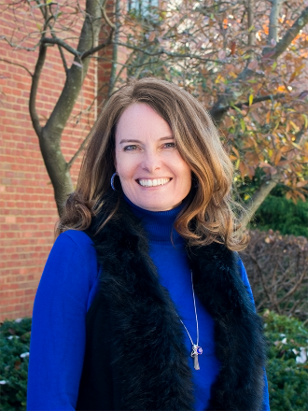
Dr. Erin Haynes is professor and chair of the Department of Epidemiology and interim chair of the Department of Preventive Medicine and Environmental Health. She is also deputy director of the UK Center for Appalachian Research in Environmental Sciences and associate director of the UK Center for Clinical and Translational Science. Her current research, funded by the National Institutes of Health/National Institute of Environmental Health Sciences (corresponding principal investigator, R01ES02644601), focuses on the impact of environmental neurotoxicant exposure in rural adolescents, and development and validation of a real-time lab-on-a-chip sensor for blood metals detection (R21/R33ES024717-02 and R01ES022933). The sensor will be validated in Southeast Chicago with a collaborator from the University of Illinois, Chicago. Haynes is particularly interested in working with community members to address environmental health issues, and developing citizen science tools to enable environmental health research. She also serves on the NIH/NIEHS Environmental Health Sciences study section, as Academic Counselor for the International Society for Exposure Science, and as senior associate editor of the Journal of Appalachian Health.

Mahesh R. Kudrimoti, MD, is a professor of radiation oncology within the Department of Radiation Medicine of the University of Kentucky College of Medicine. He also serves as program director of UK’s Radiation Oncology Residency Program. Dr. Kudrimoti has been a part of the UK College of Medicine since 1997 when he began his residency in radiation oncology here. Prior to that, he completed his internship at Robert Packer Hospital in Sayre, PA, after earning his MD from the Post-Graduate Institute of Medical Education and Research in Chandigarh, India; his MBBS from Osmania Medical College in Hyderabad, India; and his undergraduate degree from Little Flower Junior College, also in Hyderabad. Dr. Kudrimoti is certified by the American Board of Radiology in radiation oncology and is a member of the American Society for Radiation Oncology (ASTRO) and the American Brachytherapy Society (ABS). His research interests include head and neck cancers; mucositis; skin cancers including melanomas, sarcomas, and liver-directed therapy for primary and secondary tumors of the liver; pancreatic cancer; and biliary tumors.

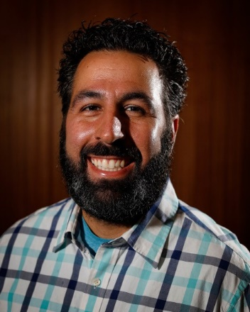
A native of Warren, Ohio, Anthony M. Limperos earned both his B.A. (2004) and M.A. (2006) in communication from Kent State University and his Ph.D. (2011) from Penn State University where he studied mass communication. Currently, he is both the Associate Dean for Graduate Programs in Communication and an Associate Professor in the Department of Communication at the University of Kentucky. Over the past 15 years, Limperos has taught both graduate and undergraduate students in courses which focus on persuasive speaking, communication theory, mass communication and research methods. Limperos’ own research program focuses on media uses and effects, with specific interests in the areas of new communication technology, video games, instruction and health. Specifically, he is interested in how contextual and technological features of new communication technologies impact various cognitive, affective and behavioral outcomes. Notable research achievements include top paper awards at the annual conferences of the Association for Education in Journalism and Mass Communication (AEJMC), the National Communication Association (NCA), and the International Communication Association (ICA). His work has been presented nationally and internationally and has been published in peer-reviewed journals such as Communication Studies, Journal of Broadcasting & Electronic Media, Mass Communication and Society, Communication Yearbook, Computers in Human Behavior, Computers & Education, Presence, Games for Health, and others.

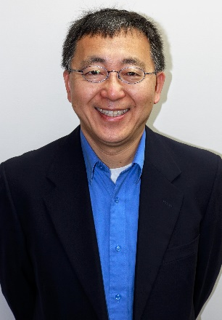
Dr. Xiaoqi Liu is the current Chair and Professor of Department of Toxicology and Cancer Biology, Lucille P. Markey Endowed Chair in Oncology Research, Markey Cancer Center at University of Kentucky. Dr. Liu has a broad background in cancer biology, with specific training and expertise in signaling transduction, cell cycle regulation, DNA damage repair, and therapy resistance in the context of prostate cancer (PCa). Dr. Liu received his BS in chemistry at Peking University in 1991. Dr. Liu received his PhD at Washington State University in 1999 by working on DNA repair of UV-induced DNA damage. Dr. Liu did his post-doctoral training at Harvard University by working on signal transduction in mitosis, particular polo-like kinase 1 (Plk1). Dr. Liu started his independent laboratory at Purdue University in 2016 by focusing on understanding the regulation of Plk1 in cancer cells. Dr. Liu has published 95 peer-reviewed research articles so far. Dr. Liu’s research program has been well funded by various agencies including NSF, ACS, and NIH. At this moment, Dr. Liu has four active R01s, all of which are prostate cancer-focused. In short, Dr. Liu has established his reputation as one of major contributors of the Plk1 field over the last 20 years. In 2018, Dr. Liu was recruited to University of Kentucky as Chair of Department of Toxicology and Cancer Biology.

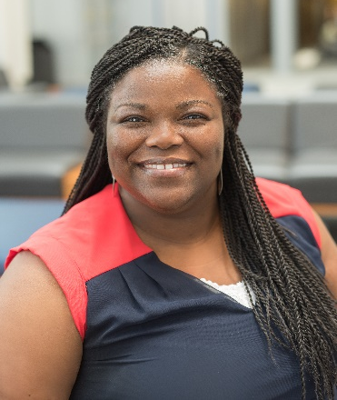
Dr. Trenika Mitchell received her Doctor of Pharmacy degree from the University of Mississippi. Upon graduation, she completed a Pharmacy Practice Residency at the University of Kentucky Chandler Medical Center. She is currently a clinical assistant professor in the University of Kentucky’s Pharmacy Practice and Sciences Department and is the Assistant Dean for Diversity and Inclusion for the College of Pharmacy. Dr. Mitchell co-coordinates and teaches students about various aspects of institutional pharmacy practice.

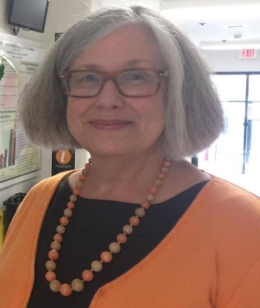
Dr. Janet Mullins joined the University of Kentucky College of Agriculture, Food, and Environment in 1997 as a Food & Nutrition Specialist. She is a Registered Dietitian and advocate for healthy, sustainable lifestyles. Her academic appointment as Extension Professor is in the Department of Dietetics and Human Nutrition where she currently serves as Chair.
She works to translate research into consumer and community programs promoting healthy eating. She has interest in program evaluation, program development using a multi-disciplinary approach and socio-ecological model, food systems, healthy weight, and sustainable eating. She works to strengthen local food systems and access to healthy foods. As a participant in Universities Fighting World Hunger, she works on campus and with other colleges and universities to incorporate hunger advocacy into academic and outreach programs. She teaches graduate courses in community program development and food systems, as well as leading an Education Abroad course to Ghana in West Africa.
Dr. Mullins received a B.S. in Dietetics with High Distinction from University of Kentucky, M.S. in Food Science is from University of California – Davis, and Ph.D. in Nutrition and Food Science from Kansas State University. She collaborates with others on sponsored projects supported by the Centers for Disease Control and Prevention, National Institutes of Health, and US Department of Agriculture.
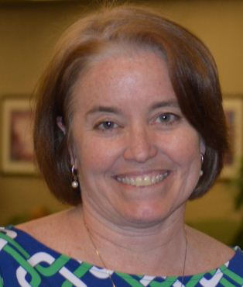
Anne D. Olson received her bachelor’s degree from the University of Florida, her master’s degree in audiology from the University of Texas at Austin and her PhD in Rehabilitation Sciences from the University of Kentucky. She has focused her scholarly efforts in clinical research as it relates to Aural Rehabilitation for adults with hearing loss. She is currently an Associate Professor and serving as Department Chair in Communication Sciences and Disorders Division Director for the CSD program.

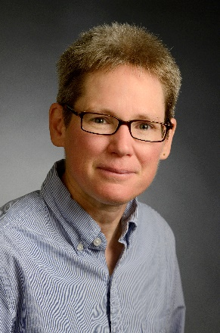
Ellen D.B. Riggle is Professor and Chair of Gender and Women's Studies, and Professor of Political Science. Her research interests include positive identity, the effects of minority stress on the well-being of LGBTQ individuals and same-sex couples, and the impact of law, legal debates, and policy issues on LGBTQ individuals and same-sex couples. Dr. Riggle received her B.A. from Purdue University and her A.M. and Ph.D. from the University of Illinois at Champaign-Urbana. Dr. Riggle is the recipient of the 2017 William B. Sturgill Award for "outstanding contributions to graduate education" from the Graduate School of the University of Kentucky. She is a Fellow of the American Psychological Association (Division 44). Dr. Riggle is co-author of A Positive View of LGBTQ: Embracing Identity and Cultivating Well-Being (with Sharon Rostosky; Rowman & Littlefield, 2012). A Positive View of LGBTQ received the Distinguished Book Award for 2012 from Division 44 of the American Psychological Association. Her latest book, Happy Together: Thriving as a Same-Sex Couple in Your Family, Workplace, and Community (with Sharon Rostosky) was published by the American Psychological Association Life Tools Series in 2015. For more information about Dr. Riggle's research, please visit www.PrismResearch.org.

Dr. Jonathan Thomas joined the STEM Education faculty in 2015. He holds a B.A. in Elementary Education from the University of Kentucky, an M.Ed. in Educational Leadership and an Ed.D. in Mathematics Education, both from the University of Cincinnati. Prior to joining the STEM Education Department at UK, Dr. Thomas served as an assistant professor of mathematics education at the Northern Kentucky University as well as a faculty associate for the Kentucky Center for Mathematics (www.kymath.org). Dr. Thomas has also served as a mathematics intervention teacher in public, private, and charter schools in the greater Cincinnati metropolitan area, and is presently serving on the board of directors for the U.S. Math Recovery Council.
Presently, Dr. Thomas’ current research interests include investigating responsive mathematics teaching practices, non-verbal patterns of mathematical interaction, and cognitive progressions of children’s mathematical construction Dr. Thomas continues his relationship with the Kentucky Center for Mathematics as a faculty associate and serves as a liaison between the center and stakeholders in mathematics teacher preparation across the commonwealth

Dr. David Thornton graduated with a Doctorate of Dental Medicine (DMD) from UKCD in 2000. After working 12 years in private dental practice, he joined UKCD as a part-time faculty member. In 2016, Thornton began serving in the role of a full-time team leader in the college’s Division of Comprehensive Care, where he later became chief of the division in 2017. In 2018, he also served as assistant dean of Pre-Doctoral Clinics, during which time he oversaw extensive renovations to the DMD Student Clinic areas and the expansion of the clinic’s use of digital technology as a regular part of patient care. In January 2018 Dr. Thornton became the Associate Dean of Clinical Affairs for the College of Dentistry.

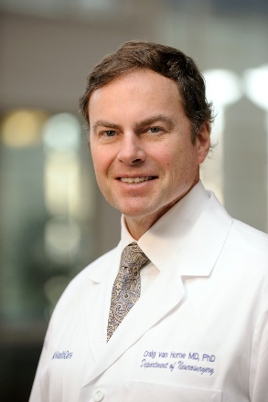
Dr. Craig van Horn is a nationally and internationally recognized expert in neurosurgery who specializes in the diagnosis and treatment of movement disorders. His research focuses on innovative surgical treatment strategies for Parkinson’s disease. Dr. van Horne completed his residency in neurosurgery at Brigham and Women’s Hospital in Boston, where he later served on the neurosurgery faculty. After 20 years in Boston, he moved to Kentucky to join UK HealthCare, where he practices as a neurosurgeon and serves as co-director of the Brain Restoration Center (BRC), part of the Kentucky Neuroscience Institute. As a leader of the BRC, van Horne collaborates with a multidisciplinary team that is helping patients find relief from movement disorder symptoms while also pursuing innovative treatments in the fight against Parkinson’s. Dr. van Horne is the Virginia T. Barrow Endowed Chair at UK and a professor of neurosurgery in the UK College of Medicine.

Dr. Mark Williams has been a faculty member in the Department of Horticulture at the University of Kentucky since 2001 and has been the Interim Departmental Chair since July 2018. Dr. Williams has conducted a range of experiments in conventional and organic farming, from optimizing the production of direct-marketed vegetables to developing control options for specific pest problems in cucurbits, peppers, tomatoes and apples. In addition to research he is committed to student learning, and led the development of the UK Sustainable Agriculture Undergraduate Program. As part of these efforts he established and is the Director of the 30-acre UK Organic Farming Unit, which houses a community supported agriculture (CSA) program (https://ukcsa.wordpress.com/) and associated student. apprenticeship

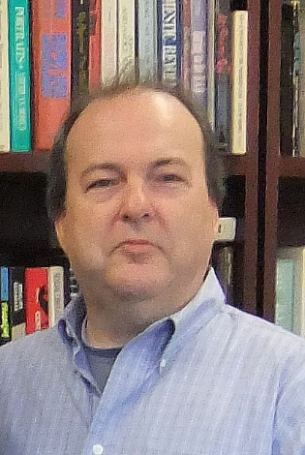
Ed Woolery is professor of Geophysics and Chair in the University of Kentucky’s Department of Earth and Environmental Sciences. Ed is in his 19th year, the last seven of which has been as the Director of Graduate Studies. Before returning to UK he spent nearly eight years with the U.S. Army Corps of Engineers as an engineering geologist and civil (geotechnical) engineer. He also served two years as a senior research scientist for the Kentucky Geological Survey’s Geologic Hazards Section. Ed’s educational background includes a BS in Geology from Eastern Kentucky University and a BSCE from the University of Kentucky in Civil Engineering. He also obtained the MS and PhD in Geological Sciences (Geophysics) from the University of Kentucky. His research interests include strong-ground motion seismology, near-surface geophysics, and paleo seismology. These field-based endeavors have largely been pursued in the Mississippi and Wabash river valleys of the central U.S., and to a lesser extent along the Tibetan Plateau of northwestern China. More recently he has developed new, but allied interests in high-resolution geophysical imaging of paleolake and extant lake environments in the eastern High Sierra (CA) and Grand Tetons (WY) related to paleoclimate and dynamic landscape response.

Co-Directors

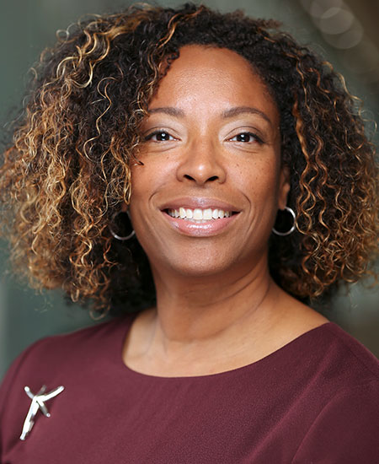
Dr. Nicole Thorne Jenkins is the Executive Associate Dean for Administration, Faculty, and Research and the Von Allmen Endowed Chair of Accountancy in the Gatton College of Business and Economics at the University of Kentucky. She has been a member of the faculty at the University of Kentucky since 2012 and held prior appointments at Vanderbilt University and Washington University in St Louis. Dr. Jenkins received her PhD in accounting from the University of Iowa and she completed her undergraduate work in accounting and finance at Drexel University. Her research interests include compensation peers, audit failures, the costs/benefits of share repurchase, the effect of social networks on performance outcomes. Her teaching experience has focused on financial reporting topics in both executive education, graduate and undergraduate programs. Dr. Jenkins is a certified public accountant and is the 2018-2019 President of the Financial Accounting & Reporting Section of the American Accounting Association. Prior to becoming an academic, she was an auditor at PriceWaterhouse and Coopers & Lybrand. Additionally, she consults and serves as an expert witness in matters related to financial reporting, valuation and estimation of damages.

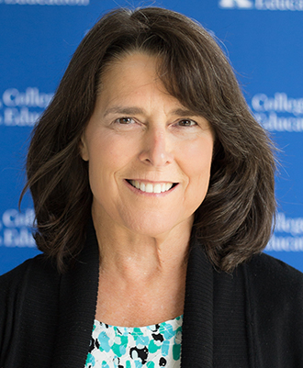
Dr. Melody P. Noland received her Ph.D. in Health Education from the University of Maryland in 1982. Her areas of research interest focus primarily on tobacco prevention with a special focus on tobacco prevention with youth who live in tobacco-producing areas. Dr. Noland teaches courses in school health education, specifically sexuality education, drug education, methods of teaching health and others.

